**Title of the paper <Times New Roman><Font Size 12><Bold & Center Align>**

First Author1*, Second Author2, Third Author2

<Times New Roman><Font Size 10><Center Align>

1 Designation, University & Address

2 Designation University & Address

* Corresponding Author: Tel (+91)XXXXXXXX ;Email ID : [xxxxxx@yyy.com](mailto:xxxxxx@yyy.com)

**Abstract:** The abstract should briefly summarize the main contents of your contribution. Recommended line spacing is 1.0 and font Times new roman using font size 10

**Keyword:** Maximum 5 keyword separated by semicolon

1. **Introduction**

The paper should be formatted in A4 format (210 mm x 297 mm) with page margins of 25 mm on the left and right sides and 25 mm on the top and bottom. The maximum allowed size is 6 pages. Pages must not be numbered because it will be done during the edition process for the full preprint volume. The first page must begin with the paper title in capital letters centered. All authors' names and affiliations appear just below the title. The email address is only given for the first author. An abstract and keywords directly follow.

The text should be divided in several sections, e.g. INTRODUCTION, DATA AND METHODS (or MODEL SETUP for numerical modelling papers), RESULTS and CONCLUSION. The title of each section should be in capital letters. Sections can be divided in sub-sections with subtitles. The text must be in a double column format. For the body, the text must be single-spaced and justified, using preferably Times New Roman font. Sizes are specified at various locations. It should be structured in paragraphs; new paragraphs begin indented without an empty line. The paper should be written in English. SI units should be used.

Communicate your work clearly. If you are not fully proficient in English, consider using an English language editing service before submitting your article. An expert editing service can help you refine the use of English in your article, so you can communicate your work more effectively.

2.0 Materials and Methods (TNR, Bold, 10pt)

The methodology must be clearly stated and described in sufficient detail or with sufficient references.

1. Results and Discussion (TNR Bold, 10pt)

The findings and arguments of the work should be explicitly described and illustrated. Supporting figures, tables and images of the

All the tables, images and figures should be centered. Figures and images should be numbered and figure headers should be placed under the figure or image; as for the tables, they should also be numbered and the table header should be placed at the top. References (if any) of the tables, figures and images should be presented right under the tables, figures and images in the form of author surname and publication date.

**3.1. Tables and figures**

Tables and figures should appear in one column of a page and be numbered consecutively. Figures and texts may appear on the same page, and a centered caption should appear directly beneath the figure. It is preferable that figures be mounted in portrait style and figure captions are no longer than two lines. On figures showing graphs, both axes must be clearly labeled (including units if applicable).

Tables should be designed to have a uniform style throughout the paper, following the style shown in Table 1. Table captions should be in 10pt “Time News Roman” bold, centered, and the texts in Table should be set in 9pt “Time News Roman” font.

**Table 1. Caption heading for a table should be placed at the top of the table and within table width.**

(Use “time news roman” font, size 09pt, No spacing after table title)

|  |  |  |  |  |
| --- | --- | --- | --- | --- |
|  | A | B | C | D |
|  |  |  |  |  |
| A | Aa | Ab | Ac | Ad |
| B | Ba | Bb | Bc | Bd |
| C | Ca | Cb | Cc | Cd |
| D | Da | Db | Dc | Dd |
| E | Ea | Eb | Ec | Ed |
|  |  |  |  |  |

Authors are advised to prepare their figures in either black and white or color. Please prepare the figures in high resolution (300 dpi) for half-tone illustrations or images. Pictures must be sharp enough otherwise they will be rejected. Figures must be originals, computer-generated or drafted, and placed within the text area where they are discussed. Figure 1 shows one example. Figure captions should be in 10pt “Time News Roman” font, bold, centered. When applicable, the texts in graphs, illustrations or images should be set in 8pt “Time News Roman” font.

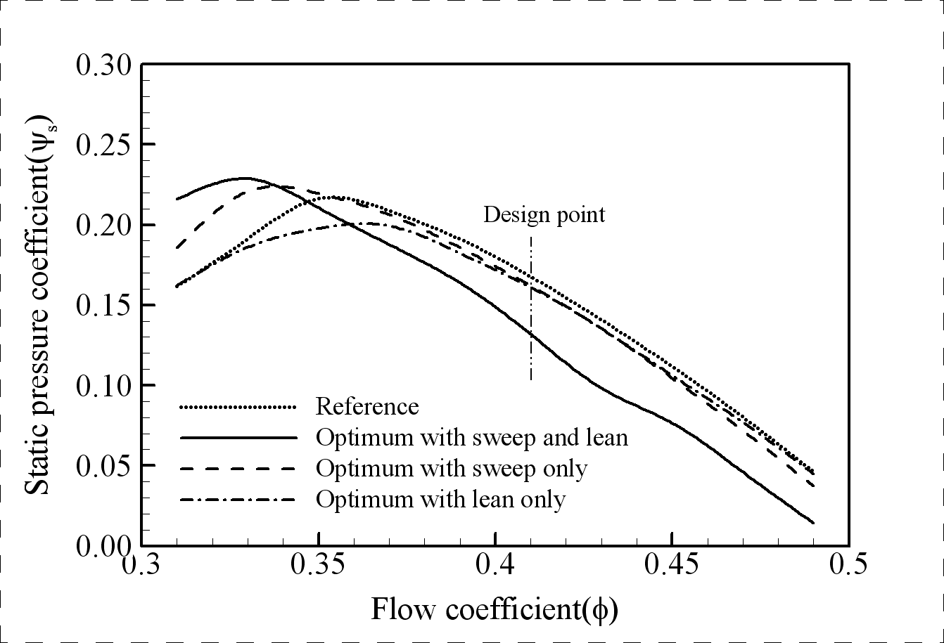

**Figure 1. The caption heading for a figure should be placed below the figure and within figure/illustration width.** (Use “Time News Roman” font, size 9pt, no spacing between title and figure)

**3.1 Equations**

Equations should be centered and numbered consecutively, as in Eq. [1]. An alternative method is given in Eq. [2] for long sets of equations where only one referencing equation number is wanted.

|  |  |
| --- | --- |
|  |  |
|  |  |
| (2) |  |

**3.4 Abbreviations and Acronyms (TNR Bold, 12pt)**

Define abbreviations and acronyms the first time they are used in the text, even after they have already been defined in the abstract. Abbreviations such as IEEE, SI, ac, and dc do not have to be defined. Abbreviations that incorporate periods should not have spaces: write “C.N.R.S.,” not “C. N. R. S.” Do not use abbreviations in the title unless they are unavoidable (for example, “IEEE” in the title of this article).

**3.5. Algorithms**

Algorithms should be numbered and include a short title. They are set off from the text with rules above and below the title and after the last line.

Z:\Indesign Projects\005 Series\03 OA Word templates\Work\TJ\Work\Fig3.tif

**4.0 Conclusion (TNR Bold, 12pt)**

Conclusions should include (1) the principles and generalisations inferred from the results, (2) any exceptions to, or problems with these principles and generalisations, (3) theoretical and/or practical implications of the work, and (5) conclusions drawn and recommendations.

References

1. Author, F.: Article title. Journal 2(5), 99–110 (2016).
2. Author, F., Author, S.: Title of a proceedings paper. In: Editor, F., Editor, S. (eds.) CONFERENCE 2016, LNCS, vol. 9999, pp. 1–13. Springer, Heidelberg (2016).
3. Author, F., Author, S., Author, T.: Book title. 2nd edn. Publisher, Location (1999).
4. Author, F.: Contribution title. In: 9th International Proceedings on Proceedings, pp. 1–2. Publisher, Location (2010).
5. LNCS Homepage, <http://www.springer.com/lncs>, last accessed 2016/11/21.